ASSIGNMENT 2

NAME:PONSHEEBA.M

(113119UG04067)

Build a python code, Assume you get temperature and humidity values (generated with random function to a variable) and write a condition to continuously detect alarm in case of high temperature.

Input:

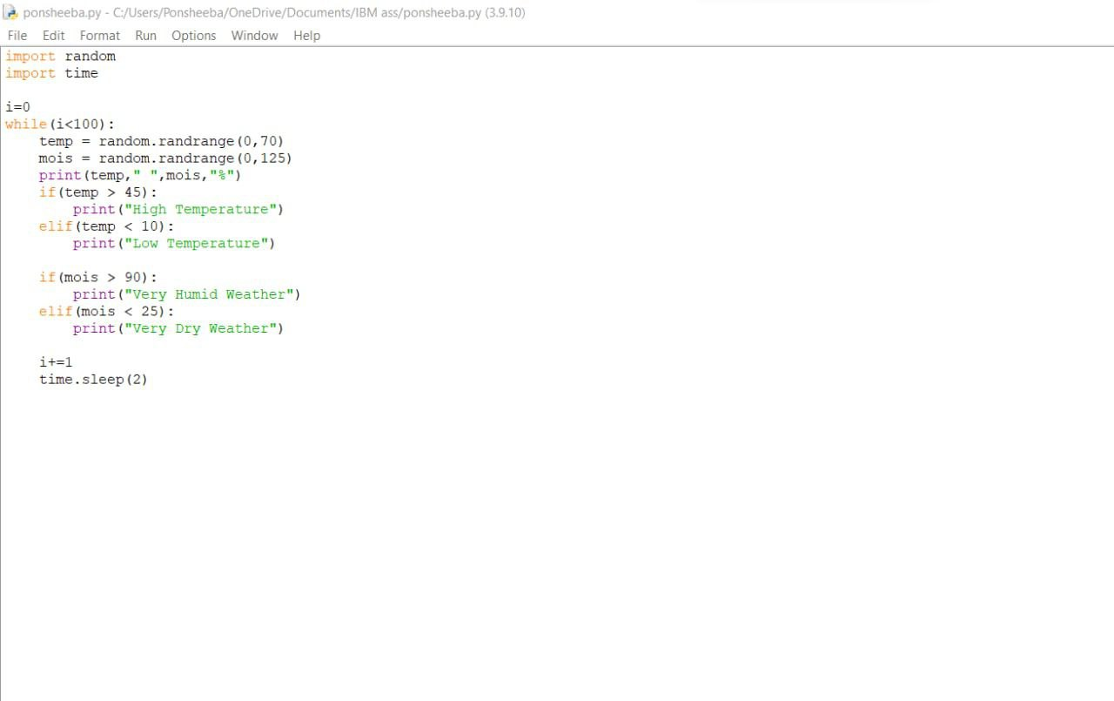

OUTPUT:

